**Manual unit test for Main_Menu.py**

|  |  |  |  |  |  |
| --- | --- | --- | --- | --- | --- |
| **Test Scenario** | **Test Description** | **Test Values** | **Expected**  **Outcome** | **Actual**  **Outcome** | **Justification** |
| **1.0** | Display Main menu | Run maze | Main Menu  =========  [1] Read and load maze from file  [2] View Maze  [3] Play maze game  [4] Configure current maze  [0] Exit Maze  Enter your input: |  |  |
| 2.0 | Test the program on input option 1 | Enter your input: “1”. | “Option [1] Read and load maze from file”  “Enter the name of the data file:”  . |  |  |
| 3.0 | Test the program on input option 2 | Enter your input: “2”. | ['X', 'X', 'X', 'X', 'X', 'X', 'X', 'X']  ['X', 'O', 'O', 'O', 'X', 'O', 'A', 'X']  ['X', 'O', 'X', 'O', 'X', 'O', 'X', 'X']  ['X', 'O', 'X', 'O', 'X', 'O', 'O', 'X']  ['X', 'O', 'X', 'O', 'X', 'X', 'O', 'X']  ['X', 'O', 'X', 'O', 'X', 'O', 'O', 'X']  ['X', 'O', 'X', 'O', 'O', 'O', 'X', 'X']  ['X', 'B', 'X', 'X', 'X', 'X', 'X', 'X']  Enter your input: |  |  |
| 4.0 | Test the program on input option 3 | Enter your input: “3”. | Enter your input:3  ========================================  ['X', 'X', 'X', 'X', 'X', 'X', 'X', 'X']  ['X', 'O', 'O', 'O', 'X', 'O', 'A', 'X']  ['X', 'O', 'X', 'O', 'X', 'O', 'X', 'X']  ['X', 'O', 'X', 'O', 'X', 'O', 'O', 'X']  ['X', 'O', 'X', 'O', 'X', 'X', 'O', 'X']  ['X', 'O', 'X', 'O', 'X', 'O', 'O', 'X']  ['X', 'O', 'X', 'O', 'O', 'O', 'X', 'X']  ['X', 'B', 'X', 'X', 'X', 'X', 'X', 'X']  Location of Start (A) = (Row 1, Column 6)  Location of End (B) = (Row 7, Column 1)  Press 'W' for UP, 'A' for LEFT, 'S' for DOWN, 'D' for RIGHT, 'M' for MAIN MENU:. |  |  |
| 5.0 | Test the program on input option 4 | Enter your input: “4”. | Invalid choice. Enter 1-5  Main menu display again |  | Option 4 has popup  an error message  because our option 4  haven’t started  coded yet. |
| 6.0 | Test the program on input option 0. | Enter “Yes” on the Kill app pop-up message box | App close. |  |  |

**Manual Unit test for Read and load.py**

|  |  |  |  |  |  |
| --- | --- | --- | --- | --- | --- |
| **Test Scenario** | **Test Description** | **Test Values** | **Expected**  **Outcome** | **Actual**  **Outcome** | **Justification** |
| 1 | Open maze.csv file | Enter the name of the data file: maze.csv | Display:  Number of lines reads: 8  Enter anything to return to Main Menu |  |  |
| 2 | Leave Null on “Enter the name of the data file” | Enter the name of the data file: | Display error message “Please key in any excel file” |  | User didn’t key in any input on the name of the data file and press enter error message will occur. |

**Manual unit test for View_Maze**

|  |  |  |  |  |  |
| --- | --- | --- | --- | --- | --- |
| **Test Scenario** | **Test Description** | **Test Values** | **Expected**  **Outcome** | **Actual**  **Outcome** | **Justification** |
| 1 | Display maze from store memory after open maze.csv file from option 1 | Enter your input:2 | Display:  ['X', 'X', 'X', 'X', 'X', 'X', 'X', 'X']  ['X', 'O', 'O', 'O', 'X', 'O', 'A', 'X']  ['X', 'O', 'X', 'O', 'X', 'O', 'X', 'X']  ['X', 'O', 'X', 'O', 'X', 'O', 'O', 'X']  ['X', 'O', 'X', 'O', 'X', 'X', 'O', 'X']  ['X', 'O', 'X', 'O', 'X', 'O', 'O', 'X']  ['X', 'O', 'X', 'O', 'O', 'O', 'X', 'X']  ['X', 'B', 'X', 'X', 'X', 'X', 'X', 'X']  Enter your input: |  |  |
| 2 | Display maze from option 2 without read and load maze.csv file in option 1 | Enter your input: 2 | Display:  Enter your input: |  | Maze didn’t display because the user didn’t go option 1 to read and load the maze.csv file first. Without read and load the csv file first, maze will not be able to display because the csv file have not read yet and the stored memory will be empty. |

**Reason for manual unit testing instead of auto for developer team**

This is the error while doing automation test on mainmenu.py, view_maze.py and read and load.py except play_maze. (if you are wondering why read and load from file got no error because the whole py is not really entirely right. It should be under manual unit test because we had tried multiple way still got the same error. Therefore we had switched manual unit test. I hope this had answer your doubt. If got time we are still trying to solve it.

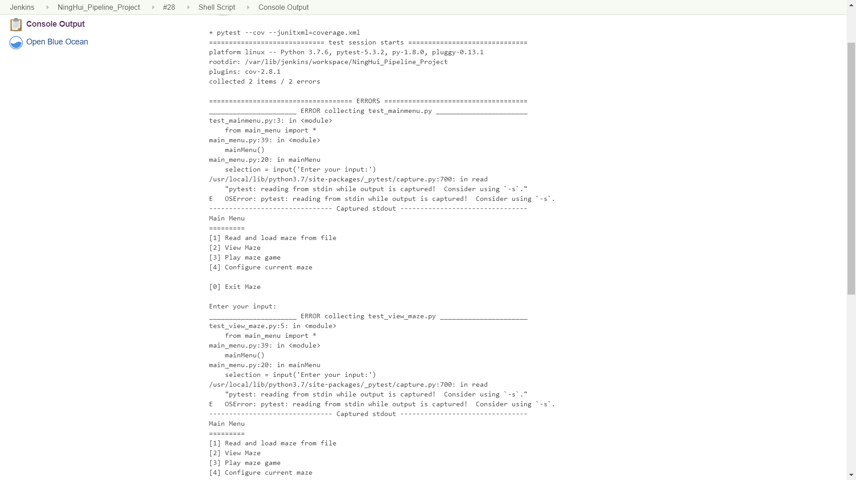

**Coverage Report**

‘